South Carolina Enterprise Information System

Interface Operations Guide (IOG)

IF384 - AR Customer Invoice Interface

Introduction

Document Purpose and Organization

The Interface Operations Guide (IOG) contains the interface specific information required for State of South Carolina Agencies to integrate with the SCEIS system. Each interface will contain a separate IOG with specific information. The IOG information will include the ADS number, description, file name(s), examples of load reports, frequency, run schedule, error conditions, etc. Additionally, the IOG will contain the file layout for the interface.

General system updates can be found on the SCEIS website, http://www.sceis.sc.gov

AR Customer Invoice Inbound Interface

Interface ADS Number | IF384
Inbound/Outbound | Inbound
Interface Title | AR Customer Invoice Inbound Interface
Interface Description | An interface and upload program is required to process AR invoices in a batch mode.  Agencies will populate a single file format from their current source systems which will either be their legacy AR sub systems or manually prepared files.  After entries have been interfaced and posted in SAP and STARS, reversals can no longer be executed. In such cases, journal entries will need to be made when and if there is a warrant ID on a transaction indicating the transaction has already posted in STARS.  There will be a batch process available to send and index images associated with the interface file – refer to the AR Batch Imaging spec for more information on this process.
Version | Version 9.0
SCEIS Point of Contact
Source System | State Agency Subsystems
Destination System | SCEIS
Interface Type | Tab-delimited text file
Mode | Asynchronous
Frequency | The Agencies will transmit the interface files as needed. Files have the option of being processed upon receipt by SCEIS (at 30 to 45 minute intervals throughout the day) or being held and processed in a batch cycle at night.

File Name(s) | Inbound interface file:  <bus. area>.<source system>.if384.custinvoice.inbound.<date/time>  Example:  e120.a1.if384.custinvoice.inbound.090706083001  ---  Error file:  <business area>.<source system>.if384.custinvoice.errors.<original date/time>.<creation date/time>  Example:  e120.a1.if384.custinvoice.errors.090706083001.090706091512  ---  Valid confirmation file:  <bus. area>.<source system>.if384.custinvoice.confirmvalid.<original date/time>.<creation date/time>  Example:  e120.a1.if384.custinvoice.confirmvalid.090706083021.090706091512  ---  Error confirmation file:  <bus. area>.<source system>.if384.custinvoice.confirmerror.<original date/time>.<creation date/time>  Example:  e120.a1.if384.custinvoice.confirmerror.090706083021.090706091512
FTP Path | Determined by the security requirements of the sending Agency.
Manual Upload | Users with appropriate permissions will be able to upload properly formatted, tab-delimited text files to the interface for processing. The SAP transaction code for uploading a customer invoice data file is ZIF384_CSTINV_UPLOAD.

Version Control

Version | Description of Change | Date
1.0 | Initial Version | 07/01/2009
2.0 | Added field for assignment number; added report examples; added manual upload information; added error file information; added source system id to file names; added ‘AR06’ Transaction Key and fields for one time customers | 07/20/2009
3.0 | Added information in the description of Reference; added information in the description of Gross Invoice Amount; added valid values for tax code, payment method and payment terms | 08/17/2009
4.0 | Corrected typo in desc to say “reversals can *no* longer be executed...”, added batch imaging information to interface description. | 09/10/2009
5.0 | Correct the valid values for tax code, add additional information. | 10/07/2009
6.0 | Added layout for valid & error return files | 12/01/2009
7.0 | Add requirements for GL validation to ensure agency is authorized to use Gl accounts listed on each record | 06/14/2011
8.0 | Update contact info | 03/13/13
9.0 | Corrections for ConfirmValid and ConfirmError layouts | 10/15/2021
File Layout

No. | Field Name | Req/  Opt | Type | Size | Format | Description
ID Segment
1 | Business Area | R | CHAR | 4 | XXXX | Agency Code - e.g. E120
2 | Source System Identifier | R | CHAR | 2 | XX | Agency specific Code to represent source system. Agencies discretion to use 2 unique characters as needed.
3 | File Date | R | DATE | 8 | YYYYMMDD | File creation date - e.g. 20090531
4 | File Time | R | TIME | 6 | HHMMSS | File creation time in 24hr format - e.g. 183622
5 | Transaction Key | R | CHAR | 4 | XXXX | Identifies the type of SAP transaction:  Key Transaction  AR01 Customer Invoice  AR03 IDT Invoices  AR05 Customer Credit  AR06 One Time Customer
6 | Approval Status | R | CHAR | 1 | X | Space. Currently not used
7 | Process | R | CHAR | 1 | X | 1 = Deferred Batch processing  Space = Immediate processing
8 | Approval Grouping | R | CHAR | 1 | X | Space. Currently not used
Header Segment
9 | Header Sequence Number | R | NUMC | 4 | 9999 | Identifies the SAP documents in the interface file. All lines making up the first document in the file should have '0001' in this field; the lines for the second document should have '0002', etc.
10 | Document Type | R | CHAR | 2 | XX | Based on Transaction Key:  Key Document Type  AR01 IR  AR03 ZJ  AR05 IG  AR06 IR
11 | Document Date | R | DATE | 8 | YYYYMMDD | Represents the Customer invoice date. Used for payment term calculation.
12 | Posting Date | R | DATE | 8 | YYYYMMDD | Represents financial posting date. Controls posting period and fiscal year. (effective date)
13 | Reference | R | CHAR | 15 | X(15) | Can be used for customer information for bill identification purposes. This field is not available for agencies to use for AR03 IDT Invoices.
14 | Header Text | R | CHAR | 25 | X(25) | Available for agency use to map legacy information. Will be stored in posted document header

Data Segment
15 | Line Item Number | R | NUMC | 3 | 999 | Identifies the detail lines within the SAP document. The first line in the document should have '001', the second line '002', etc. When a new document is started (i.e. Header Sequence Number increments), Line Item Number starts back at '001'.
16 | Customer Number | R | CHAR | 10 | X(10) | SCEIS Customer Number.
17 | Gross Invoice Amount | R | DEC | 14 | 9(11).99 | Gross Invoice amount (field is 14 digits including a decimal point and 2 decimal places). This should always be a positive number even for AR05 Customer Credits.
18 | Calculate Tax | O | CHAR | 1 | X | X = Tax to be calculated automatically  Space = Tax will not be calculated
19 | Payment Term | O | CHAR | 4 | XXXX | Will default from vendor master but can be changed to.  0001 – Payable Immediately Due net  NT30 – Net 30 days  ZSPE – Payable Immediately Due net
20 | Payment Method | O | CHAR | 1 | X | Will default from vendor master but can be changed to.  C – Check; External, NON-P/R  E – EDI Payment  S – Check; Single Pay., NON-P/R
21 | GL Account | R | CHAR | 10 | X(10) | SCEIS Chart of Accounts to be provided for crosswalk/mapping purposes.
22 | Line Item Amount | R | DEC | 14 | 9(11).99 | Line Item Amount (field is 14 digits including a decimal point and 2 decimal places)
23 | Debit/Credit indicator | R | CHAR | 1 | X | "D" = Debit  "C" = Credit
24 | Cost Center | R | CHAR | 10 | X(10) | List will be available by agency once converted to SCEIS codes
25 | Functional Area | R | CHAR | 16 | X(16) | List will be available by agency once converted to SCEIS codes
26 | Fund | R | CHAR | 10 | X(10) | List will be available by agency once converted to SCEIS codes
27 | Grant | R | CHAR | 12 | X(12) | List will be available by agency once converted to SCEIS codes. If not grant related default value is "NOT RELEVANT".
28 | Internal Order | O | CHAR | 12 | X(12) | If applicable, list will be available by agency once converted to SCEIS codes
29 | WBS | O | CHAR | 24 | X(24) | If applicable, list will be available by agency once converted to SCEIS codes
30 | Line Item Text | O | CHAR | 50 | X(50) | Available for agency use to map legacy information.
31 | Tax Code | R | CHAR | 2 | XX | O1 – A/R Sales Tax (capital letter o, number 1)  O0 – A/R Tax Exempt (capital letter o, number 0)
32 | Assignment Number | O | CHAR | 18 | X(18) | Contains optional legacy client / case / claim numbers
33 | Customer Name | O | CHAR | 35 | X(35) | Valid for transaction key ‘AR06’ (One-Time customer invoices) only
34 | Customer Street | O | CHAR | 35 | X(35) | Valid for transaction key ‘AR06’ (One-Time customer invoices) only
35 | Customer City | O | CHAR | 35 | X(35) | Valid for transaction key ‘AR06’ (One-Time customer invoices) only
36 | Customer State | O | CHAR | 3 | XXX | Valid for transaction key ‘AR06’ (One-Time customer invoices) only. For US customers, enter the 2-digit state code.
37 | Customer Postal Code | O | CHAR | 10 | X(10) | Valid for transaction key ‘AR06’ (One-Time customer invoices) only. Either 5 or 10 digit zip code allowed.
38 | Customer Country | O | CHAR | 3 | XXX | Valid for transaction key ‘AR06’ (One-Time customer invoices) only, should be ‘US’

Note: Every record on the input file contains all data fields. The ID and Header segment fields are repeated on every record.
Process Flowchart
Report Examples

There are several reports that are emailed back to the agency based on the Source System ID field. Email recipients are associated with each agency system and the reports are sent as email attachments in a PDF format. The following are examples of a notification report, a successful report and an error report. A transmittal notification report is sent when the file is received by the system. The successful and error reports are sent when the data is processed by the system. The reports may vary slightly based on the interface type, but will be similar to the examples shown.

The following is an example of a transmittal notification report:

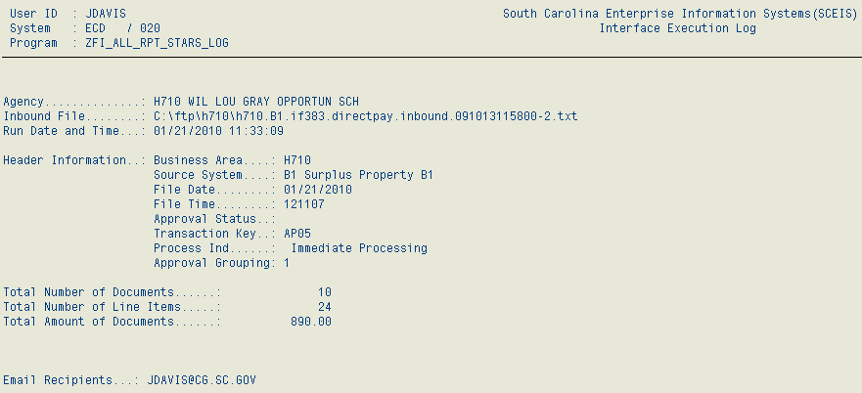

The following is an example of a successful report:

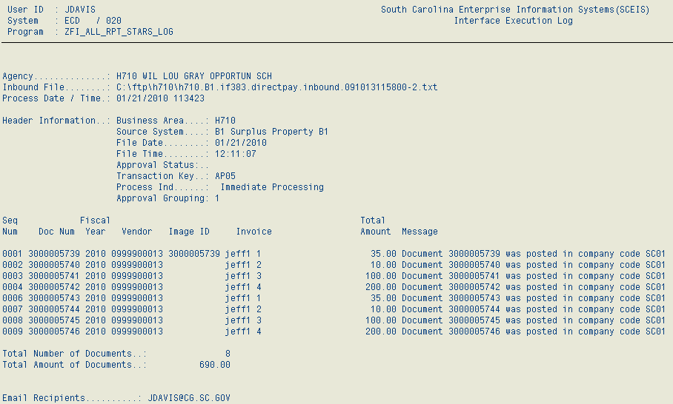
The following is an example of an error report:

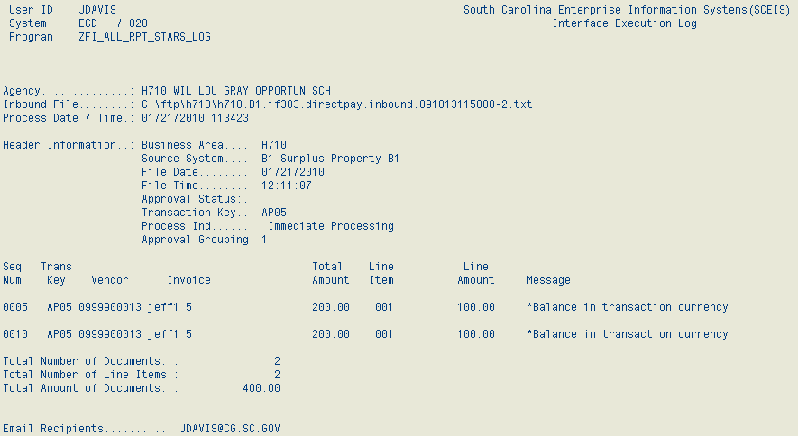
Confirmvalid text file layout

An optional valid confirmation file can be created (on/off based on source system), if requested. This will contain the documents that were posted for a specific interface file and will be written back to the same FTP folder as the inbound file. Each record on the file will be 500 bytes, padded with spaces on the end.

No. | Field Name |  | Type |  | Size | Format | Description
1 | Business Area |  | CHAR |  | 4 | XXXX | Agency Code - e.g. E120
2 | Source System Identifier |  | CHAR |  | 2 | XX | Agency specific Code to represent source system.  Note: Same as on inbound file
3 | File Date |  | DATE |  | 8 | YYYYMMDD | File creation date - e.g. 20090531
4 | File Time |  | TIME |  | 6 | HHMMSS | File creation time in 24hr format - e.g. 183622
5 | Transaction Key |  | CHAR |  | 4 | XXXX | Identifies the type of SAP transaction:  Key Transaction  AR01 Customer Invoice  AR03 IDT Invoices  AR05 Customer Credit  AR06 One Time Customer  Note: Same as on inbound file
6 | Header Sequence number |  | NUMC |  | 4 | 9999 | Identifies the SAP documents in the interface file. Note: Same as on inbound file
7 | Line Item Number |  | NUMC |  | 3 | 999 | First line item of document  Note: Same as on inbound file
8 | Customer Number |  | CHAR |  | 10 | X(10) | SCEIS Customer Number
9 | Gross Invoice Amount |  | DEC |  | 13 | 9(9).99 | Gross Invoice amount (field is 13 digits including decimal point, 2 decimal places, and a sign byte)
10 | SAP Document Number |  | CHAR |  | 10 | X(10) | SAP assigned document number
11 | Line Item Amount |  | DEC |  | 13 | 9(9).99 | Line Item Amount (field is 13 digits including a decimal point, 2 decimal places, and a sign byte)
12 | Debit/Credit Indicator |  | CHAR |  | 1 | X | "S" = Debit  "H" = Credit
13 | Receive error file |  | CHAR |  | 1 | X | Setting on Source control table for agency receiving an error file ( “X” = receive error file )
14 | Fiscal Year |  | DEC |  | 4 | 9999 | Fiscal year of Document
15 | Header Text |  | CHAR |  | 25 | X(25) | Note: Same as on inbound file
16 | Message |  | CHAR |  | 132 | X(132) | Any warning messages that are returned from posting and a message stating document was successfully posted.
Confirmerror text file layout
An optional error confirmation file can be created (on/off based on source system), if requested. This will contain the documents that had errors for a specific interface file and will be written back to the same FTP folder as the inbound file. Each record on the file will be 500 bytes, padded with spaces on the end.

No. | Field Name | Type | Size | Format |  | Description
1 | Business Area | CHAR | 4 | XXXX |  | Agency Code - e.g. E120
2 | Source System Identifier | CHAR | 2 | XX |  | Agency specific Code to represent source system.  Note: Same as on inbound file
3 | File Date | DATE | 8 | YYYYMMDD |  | File creation date - e.g. 20090531
4 | File Time | TIME | 6 | HHMMSS |  | File creation time in 24hr format - e.g. 183622
5 | Transaction Key | CHAR | 4 | XXXX |  | Identifies the type of SAP transaction:  Key Transaction  AR01 Customer Invoice  AR03 IDT Invoices  AR05 Customer Credit  AR06 One Time Customer  Note: Same as on inbound file
6 | Header Sequence number | NUMC | 4 | 9999 |  | Identifies the SAP documents in the interface file.  Note: Same as on inbound file
7 | Line Item Number | NUMC | 3 | 999 |  | First line time of document  Note: Same as on inbound file
8 | Customer Number | CHAR | 10 | X(10) |  | SCEIS Customer Number
9 | Gross Invoice Amount | DEC | 13 | 9(9).99 |  | Gross Invoice amount (field is 13 digits including decimal point, 2 decimal places, and a sign byte)
10 | SAP Document Number | CHAR | 10 | X(10) |  | Blank for Error File
11 | Line Item Amount | DEC | 13 | 9(9).99 |  | Line Item Amount (field is 13 digits including a decimal point, 2 decimal places, and a sign byte)
12 | Debit/Credit Indicator | CHAR | 1 | X |  | "S" = Debit  "H" = Credit
13 | Receive error file | CHAR | 1 | X |  | Setting on Source control table for agency receiving an error file
14 | Fiscal Year | DEC | 4 | 9999 |  | Fiscal year of Document
15 | Header Text | CHAR | 25 | X(25) |  | Note: Same as on inbound file
16 | Message | CHAR | 132 | X(132) |  | Any error messages that are returned from posting.
Miscellaneous Processing Notes

- The file format is a TAB-delimited text file.
- All records within the file have three parts.
  - ID Segment contains systems information to specify how the file will be processed. It also contains information to uniquely identify a transaction by the source system that created it. Important: The data in the ID Segment should be the same for every record on the file.
  - HEADER Segment has the header level information for the SCEIS transaction.
  - DATA Segment contains the line item information for the SCEIS transaction.

- Each file sent for processing will be uniquely identified by the combination of Business Area, Source System ID, File Date and File Time. Each combination of this data will be logged by the system and any subsequent files sent with same combination will be rejected as duplicates.

- Agency contact email addresses will need to be provided to SCEIS for each agency / subsystem that will use the interface. This information will be requested as part of a testing and acceptance process for each agency system. Transmittal controls, Valid / Error reports, etc will be emailed to these designated users as files are processed by the interface. In the examples below, notifications for system “A1” would be emailed to Joe and Mary; Tom would get the emails for the “B1” system.

Agency System Email
E120 A1 joe@agency.gov
E120 A1 mary@agency.gov
E120 B1 tom@agency.gov

- As each interface file is processed, an error file (containing only the documents that do not post) will be written back to the same directory as the inbound file. The file layout of the error file is the same as the inbound file. The error codes for the documents are sent back via the error report. Agencies can opt out of this error file creation on a per-system basis

- As each interface file is processed, a Gl account validation needs to be completed. This will ensure tha the Agency is authorized to use the Gl account submitted in data Segment 21. This should be completed using the Auth Group on the Gl account master data.

General FTP Processing Notes
The preferred method of data transfer will be via secure FTP, and SCEIS will host an FTPS server for this purpose.

There will be a folder structure set up on the server for each business area. Sub-folders will be created if necessary based on the security requirements of the sending agency. Security will be set up appropriately on the folders so that users will only have access to their data.

In the example below there are separate AR and AP interface folders for business area E120. On the other hand for E160, all interfaces would use the same FTP folder - “/e160”.

/e120
/ar
/ap
/vendor
/e160
/e200
/fi
/mm

To send files to SCEIS‐inbound or receive files from SCEIS‐outbound interfaces, FTPS client software will be used on the agency side. Example FTP connection options are shown in the following print screen. (Using the CoreFTP desktop client software – in other clients, the options may be slightly different.)

For further questions/concerns regarding the File Transfer Protocol procedures. Please contact the SCEIS Interface Team at interfaces@sceis.sc.gov

